Algebra I - Midterm Review #3
Do Now:
Severe flu cases are increasing in a local hospital. The number of reported cases is shown over the span of a week in the table below.
Day, x | 1 | 2 | 3 | 4 | 5 | 6 | 7
Actual Flu Cases, y | 13 | 19 | 24 | 27 | 30 | 32 | 34

(a) Using your calculator, determine the equation of the trend line for this data set. Round all values to the nearest tenth.
b) Using the regression equation that you obtained from your calculator, predict the number of flu cases on Day 10.
(c) To the nearest hundredth, state the correlation coefficient. Using this number, describe the correlation between the two variables.
Algebra I - Midterm Review #4
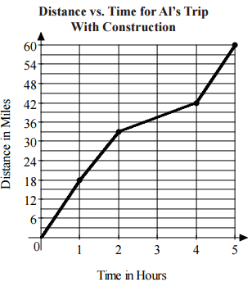
Do Now:
- Al is an avid cyclist. On a recent ride, Al encountered some road construction which caused his speed to vary as shown in the graph pictured to the right.
What was Al’s average speed for the time interval 0 ≤ t ≤ 5?

- The mathematics department sponsors Math Family Fun Night every year. In the first year, there were 35 participants. In the third year, there were 57 participants.

- Assuming the number of participants continues to increase at a constant rate, write an equation that can be used to predict the number of participants, y, for any given year, x. Only an algebraic solution will be accepted.

b) Based on your equation, how many people are expected to participate in the fifth year?

