8 Algebra CC 6-6
Essential Question: How do we graph linear relationships with restricted domains?

Do Now: In a local convenient store, rolls of paper towels sell for $1.50 each. Due to a recent shortage, the store is only allowing customers to purchase up to 5 rolls. The function rule that describes the relationship between the number of rolls of paper towels purchased (x) and the total cost (y) is y = 1.50x.

Create a table of values for this function rule. Before choosing your input values (x), think about the context of the situation. What numbers should x represent?
X  Number of Rolls | Y  Total Cost

Think about this…
Does the linear function from the Do Now have a restricted domain?
Does the linear function from the Do Now have a restricted range?
What does the graph of this function look like?

Does it make sense to connect the points?

Domain:

Range:

Graphing Linear Functions with Restricted Domains

- Graph the following linear function using the domain [-1, 3] where x is a real number.
y = 2x – 1
x | y

Represent the range of the function using an inequality statement and interval notation.
Inequality Statement:___________________________
Interval Notation: ______________________________

- Graph the following linear function using the domain 0 < x < 2 where x is a real number.

4y + 12x = 8
x | y

Represent the range of the function using an inequality statement and interval notation.
Inequality Statement:___________________________
Interval Notation: ______________________________
Defining the Domain and Range from a Graph

Consider the linear functions graphed below. Define the domain and range of the function using an inequality statement and interval notation.

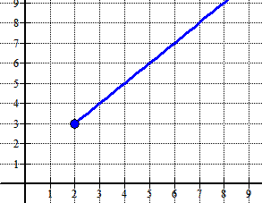
3.
Domain:

Range:

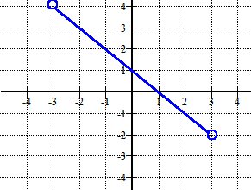
The Take Away
Linear functions with restricted domains have ______________________________ ranges. The domains and ranges of the functions can be defined using an inequality statement or interval notation.
Domain:

Range:

4.

8 Algebra CC HW # ________

- Graph the following linear function using the domain -6 < x < -2 where x is a real number.
y – x = 1

Represent the range of the function using an inequality statement and interval notation.
Inequality Statement:___________________________
Interval Notation: ______________________________

- Graph the following linear function using the domain [-8, 4] where x is a real number.
y = -0.25x + 2

Represent the range of the function using an inequality statement and interval notation.
Inequality Statement:___________________________
Interval Notation: ______________________________

